**Documentation**

**Aim :**

providing a robust foundation for managing user attendance efficiently. It includes features such as clock-in/out, break tracking, user management, and robust authorization/authentication using JWT Bearer.

The system is designed to handle Performance data seamlessly and includes error handling for a smooth user experience. The system employs role-based authentication for manual request approval && leave Request Approval && Insert Event Designated roles are responsible for approving or rejecting leave requests submitted by employees.

**Objective :**

* Facilitates easy and accurate tracking of employee attendance.
* Streamlines user management operations with CRUD functionalities.
* Ensures data security through JWT Bearer token authentication.
* Enhances overall user experience with efficient error handling.

**Database Schema :**

|  |
| --- |
| **User** |
| Username |
| Password |
| Email |
| PhoneNo |
| Adress |
| UserTypeId |
| Role |

|  |
| --- |
| **ManualRequest** |
| UserId |
| BreakType |
| ClockInTime |
| ClockOutTime |
| status |
| EmployeeRemark |

|  |
| --- |
| **Report** |
| UserId |
| CheckoutTimeId |
| AttendanceId |
| StartBreakId |
| FinishBreakID |

|  |
| --- |
| **Breaks** |
| ClockIn |
| Clockout |
| StarteBreak |
| FinishBreak |

|  |
| --- |
| **Leave** |
| UserId |
| LeaveRequestTime |
| LeaveStatusTime |
| StartLeaveDate |
| EndLeaveDate |
| LeaveType |
| Status |
| Reason |

|  |
| --- |
| **BaseEntity** |
| Id |

**Users:**

* **Employee:** Employees are usually responsible for marking their attendance Requesting Leaves Etc. through the system.
* **Admin (HR):** Admins are usually responsible for checking Attendance of the Employee and approving their attendance and approving Requested Leaves Etc. through the system.

**Events:**

* **Live Clock-In/Out Updates:** Users receive real-time notifications when colleagues clock in or out.
* **Dashboard Synchronization:** Real-time synchronization of attendance data on the user dashboard.
* **Break Notifications:** Instant notifications when a break is started or finished.
* **Request Approval/Reject Notifications:** The system also includes real-time notifications for request approval or rejection. When a user requests time off or submits any form of leave, concerned parties are instantly notified of the approval or rejection status. This feature streamlines the leave management process and provides quick feedback to users.

**Technologies Used :**

* **React.**
* **Redux/Toolkit.**
* **Thunk Middleware.**
* **Material-UI.**

**State Management :**

* **Redux Store.**
* **Actions and Reducers.**

**Api InteGration :**

* **Communication with ASP.NET Backend**
* **Authorization Headers**

**Role-Based Authentication :**

* **User Roles and Permissions**
* **Access Control in the UI**

**User Interface :**

* **Clock-In/Out Interface**
* **Break Tracking Interface**
* **User Management Interface**
* **Manual Request Approval Interface**
* **Leave Request Approval Interface**
* **Insert Event Interface**

**Deliverables :**

1. **Login/Logout**
2. **StartBreak/FinishBreak**
3. **Total Hours**
4. **Productive Hours**

**Extra Functionalities :**

1. **Event Management for Particular User.**
2. **Leave Request and Its Management.**
3. **Role Based Access to the HR(Admin) and the Employee**
4. **User Apply Manual Request.**

**Forms/Layout/Outputs :**

1. **Login Form:**

**In that form user have login with username and password.**

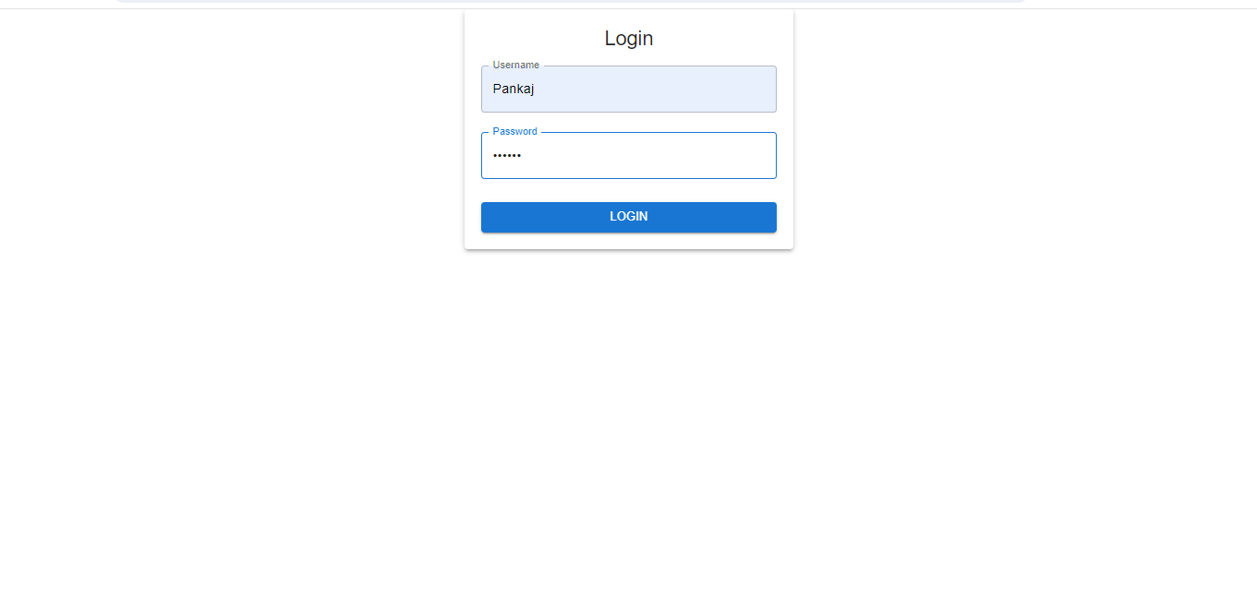

1. **Leave Application :**

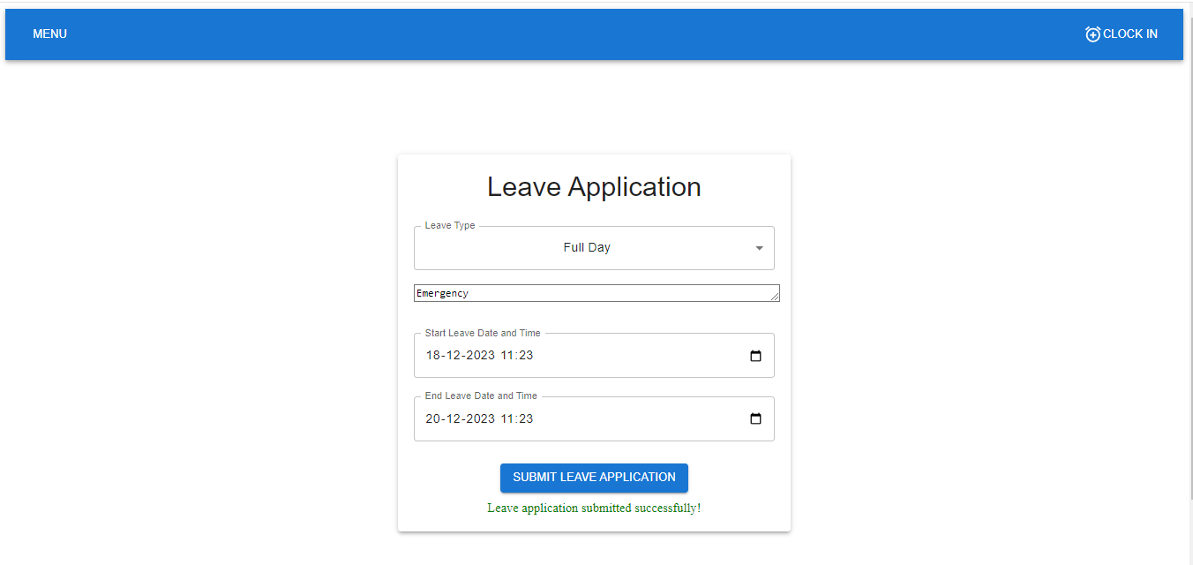**In that form user Successfully apply for leave**.

1. **Leave Approved form :**

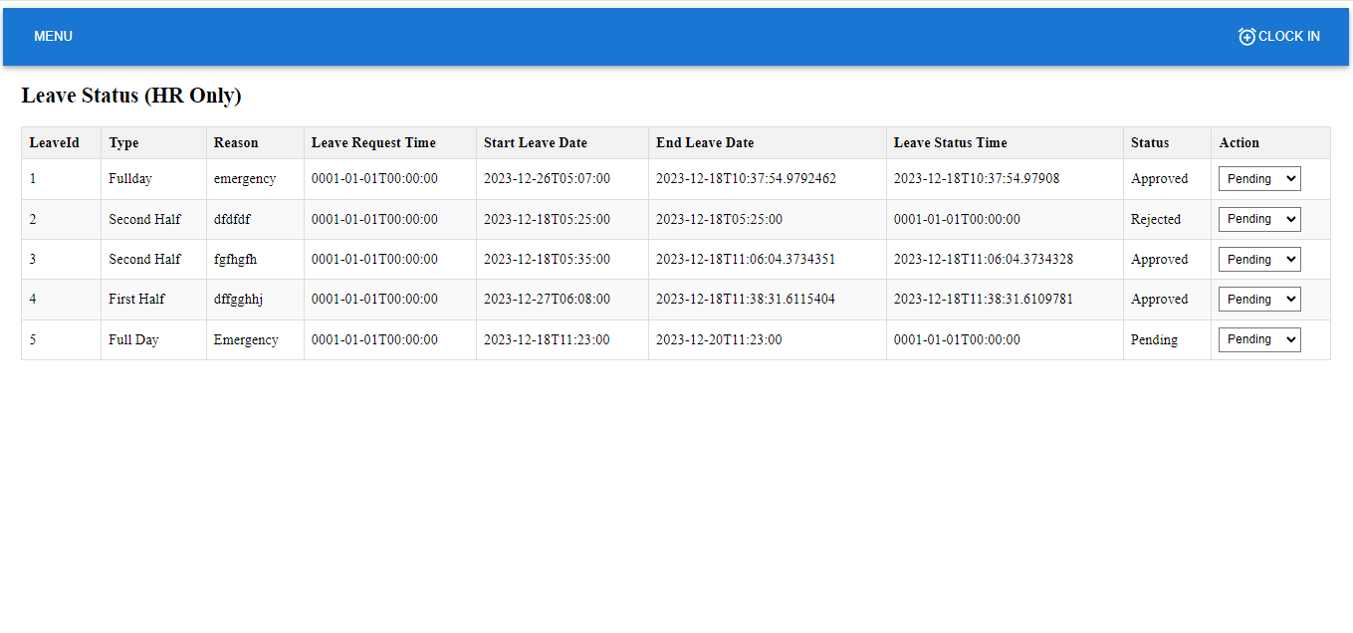**This form is leave Approved Form this form access only for HR or Admin to Approved User leave.**

1. **Leave History:**

**This form containing currently login user information such as Leave history.**

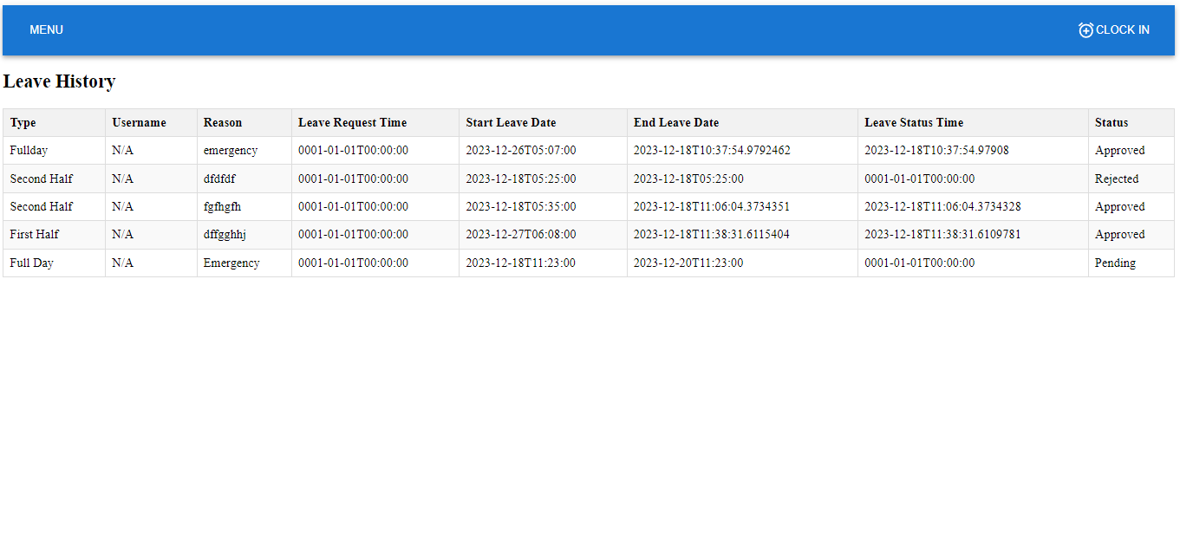

1. **Insert Manual Request :**

**In this form user apply manual request when after he/she forgot click on clockin time , clockout time , startbreak or finishbreak in that case user apply manual request to Admin.**

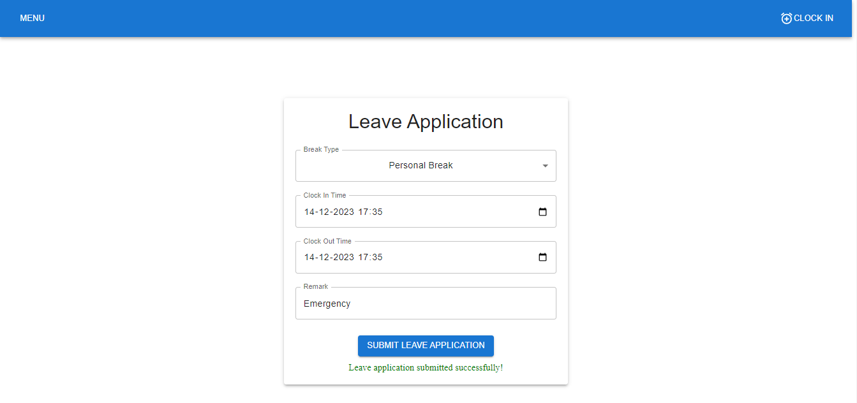

1. **Approved Manual Request:**

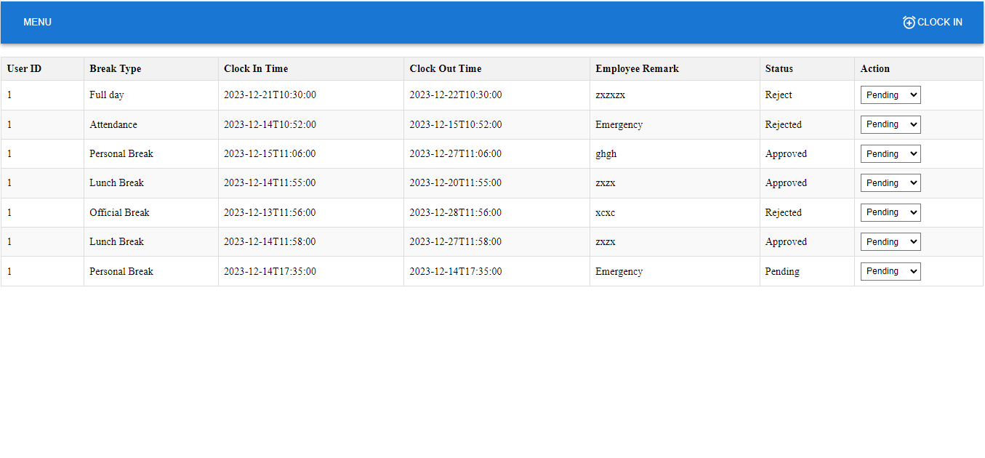**This form is accessible only for Admin or Hr in that form Hr Approved or reject manual request of user.**

1. **Manual History :**

**In that form All manual leave history display for currently login user.**

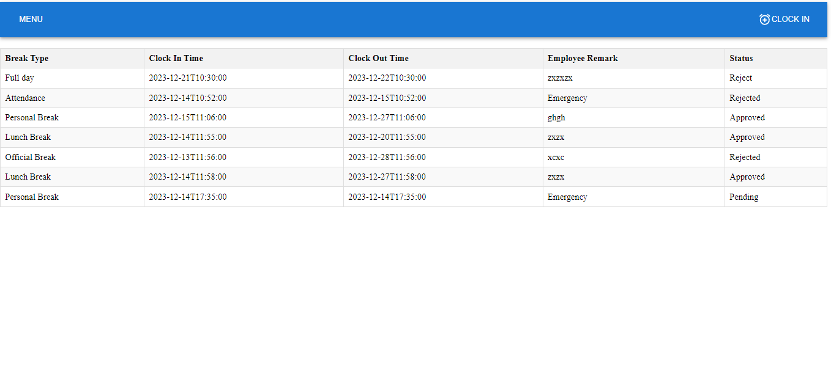

1. **Insert Event :**

**In that form HR And Admin insert event for user and also delete functionality is available.**

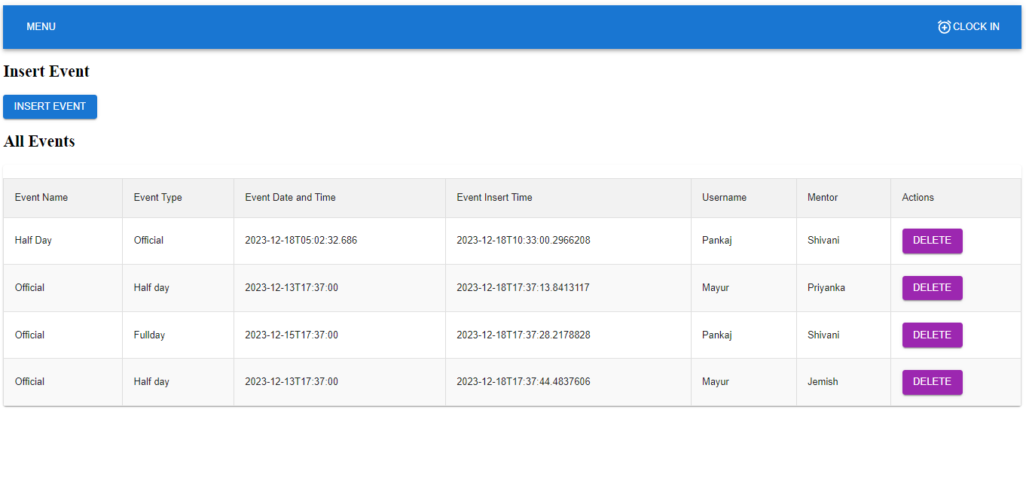

1. **Event History :**

**In that form all event are display to currently login user.**

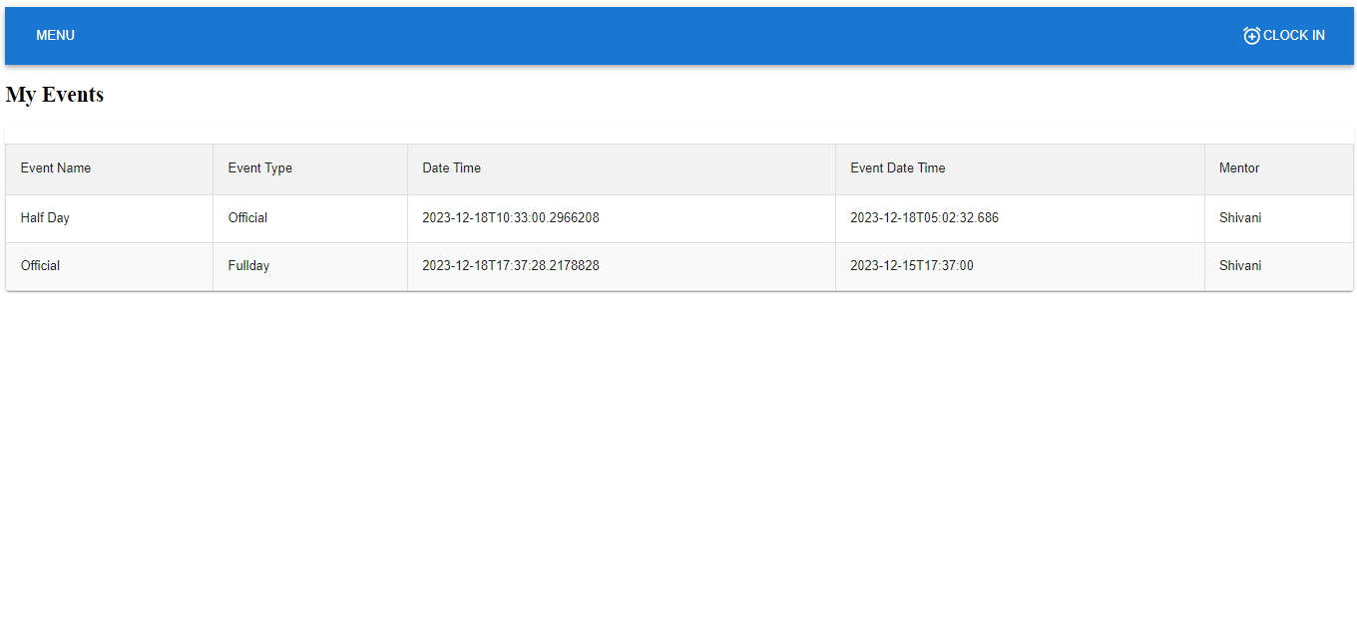

**10)Search History By UserName :**

**In that form this form access only for HR or Admin in that HR get All Previous data of user by username.**

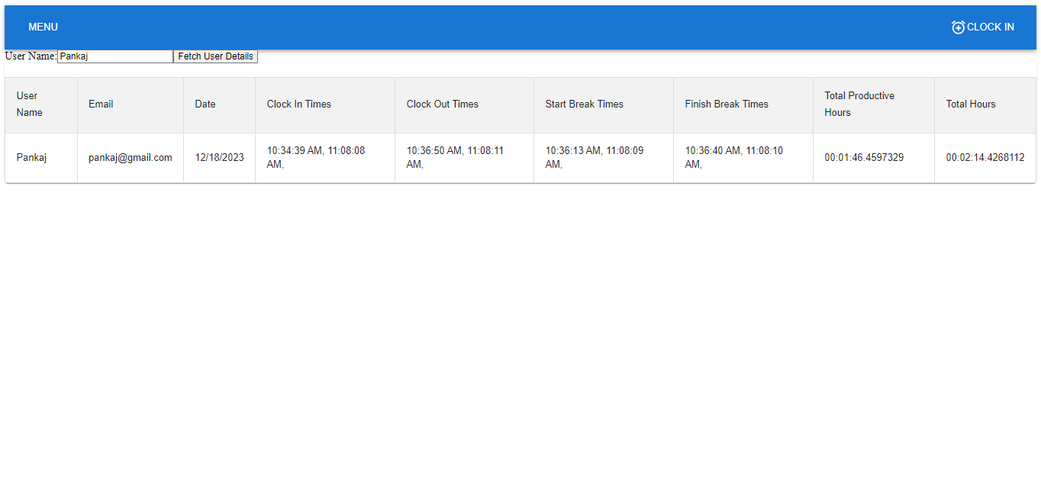

**11)User Report Card :**

**In that form user see all their previous history.**

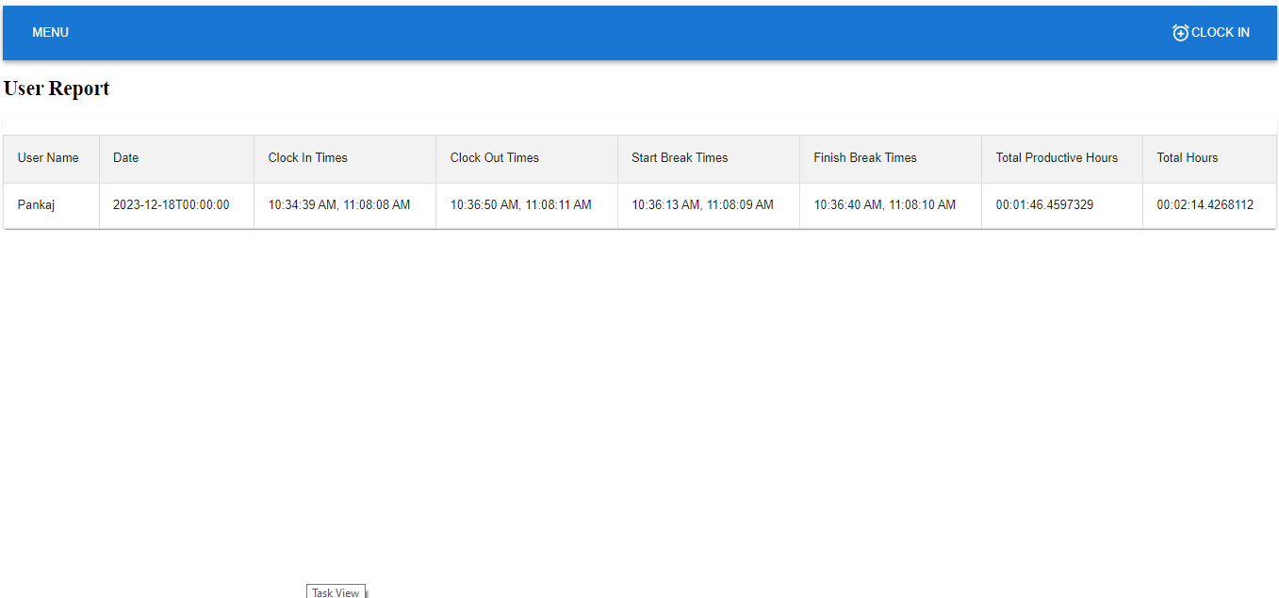

**Thank You.**